**University of Canberra- Semester 1 -2016**

**Database Design**

**Assignment 2**

**Tutorial class – Wednesday, 12:30 pm in room 22B14**

**Tutor: Amritha Bangera**

**Group members**

1. **Oliver Nguyen – u3135481**
2. **Tshering Wangchuk – u3149295**
3. **Neelu Gurung – u3151789**
4. **Kaushika Peiris – u3062367**
5. **Yasir Parvaiz – u3139364**
6. **Entity types and their attributes**
7. Student (**StudentID**, FName, LName, Street, City, PostCode, PhoneNumber, Email, DoB, Gender, StudentCategory, Nationality, SpecialNeed, AdditionalComment, CourseID)

Primary key: StudentID

Foreign key: CourseID

1. Course (**CourseID**, CourseName)

Primary key: CourseID

1. StudentVehicle (**RegistrationNo**, Type, Make, Model, StudentID)

Primary key: RegistrationNo

Foreign key: StudentID

1. StaffVehicle (**RegistrationNo**, Type, Make, Model, StaffID)

Primary key: RegistrationNo

Foreign key: StaffID

1. VisitorVehicle (**RegistrationNo**, Type, Make, Model, VisitorID)

Primary key: RegistrationNo

Foreign key: VisitorID

1. Staff (**StaffID**, FName, LName, Street, City, PostCode, PhoneNumber, Email, DoB, Gender, StaffCategory, OfficeID)

Primary key: StaffID

Foreign key: OfficeID

1. Office (**OfficeID**, OfficeName, Location)

Primary key: OfficeID

1. CarParkStaff (**CarParkStaffID**, FName, LName, Street, City, PostCode, PhoneNumber, Email, DoB, Gender, StaffCategory, RoleID, OfficeID)

Primary key: CarParkStaffID

Foreign key: RoleID, OfficeID

1. Role (**RoleID**, RoleName)

Primary key: RoleID

This table is used to store role ID and role name of staffs working for car parks

Role names can be Manager, Superviser, Inspecter, Cleaner, Accountant, .etc

1. CarPark (**CarParkID**, Name, LocationID, Size, Capacity, ParkingTypeID, CarParkStaffID)

Primary key: CarParkID

Foreign key: CarParkStaffID, ParkingTypeID

1. ParkingType (**ParkingTypeID**, TypeName);

Primary key: ParkingTypeID

1. CarParkSpace (**SpaceID, CarParkID**, MonthlyFee)

Primary key: SpaceID & CarParkID

Foreign key: CarParkID

1. MembershipForStudent (**MembershipForStudentID**, Time, Fee, ParkingTypeID)

Primary key: MembershipID

Foreign key: ParkingTypeID

1. MembershipForStaff (**MembershipForStaffID**, Time, Fee, ParkingTypeID)

Primary key: MembershipID

Foreign key: ParkingTypeID

1. CasualRate (**CasualRateID**, ParkingTypeID, Fee)

Primary key: CasualRateID

Foreign key: ParkingTypeID

1. StudentLease (**StudentLeaseID**, Duration, StudentID, ParkingTypeID, StartDate, EndDate, MembershipForStudentID)

Primary key: StudentLeaseID

Foreign key: ParkingTypeID, StudentID, MembershipForStudentID

1. StaffLease (**StaffLeaseID**, Duration, StaffID, ParkingTypeID, StartDate, EndDate, MembershipForStafftID)

Primary key: StaffLeaseID

Foreign key: ParkingTypeID, StaffID, MembershipForStaffID

1. StudentInvoice (**StudentInvoiceID**, StudentLeaseID, PaymentDueDate)

Primary key: StudentInvoiceID

Foreign key: StudentLeaseID

1. StaffInvoice (**StaffInvoiceID**, StaffLeaseID, PaymentDueDate)

Primary key: StaffInvoiceID

Foreign key: StaffLeaseID

1. StudentPayment (**StudentPaymentID**, StudentInvoiceID, DateofPay, Amount, PayMethod, CarParkStaffID)

Primary key: StudentPaymentID

Foreign key: StudentInvoiceID, CarParkStaffID

1. StaffPayment (**StaffPaymentID**, StaffInvoiceID, DateofPay, Amount, PayMethod, CarParkStaffID)

Primary key: StaffPaymentID

Foreign key: StaffInvoiceID, CarParkStaffID

1. Visitor (**VisitorID**, FName, LName, PhoneNo, DoB, Gender, Email, Street, City, PostCode)

Primary key: VisitorID

1. VisitorPayment (**VisitorPaymentID**, Amount, DateofPay, PayMethod, VisitorID, CarParkStaffID)

Primary key: VisitorPaymentID

Foreign key: VisitorID, CarParkStaffID

1. StudentDoctorCertificate (**StudentDoctorCertificateID**, ReceiveDate, StudentID)

Primary key: StudentDoctorCertificate

Foreign key: StudentID

1. StaffDoctorCertificate (**StaffDoctorCertificateID**, ReceiveDate, StaffID)

Primary key: StaffDoctorCertificate

Foreign key: StaffID

1. VisitorDoctorCertificate (**VisitorDoctorCertificate**, ReceiveDate, VisitorID)

Primary key: VisitorDoctorCertificate

Foreign key: VisitorID

1. InspectSchedule (**InspectScheduleID**, Date, CarParkID)

Primary key: InspectScheduleID

Foreign key: CarParkID

1. Inspection (**InspectionID**, Date, Indication, Comment, CarParkID, CarParkStaffID)

Primary key: InspectionID

Foreign key: CarParkID, CarParkStaffID

1. Cleaning (**CleaningID**, Date, CarParkStaffID, CarParkID)

Primary key: CleaningID

Foreign key: CarParkStaffID, CarParkID

1. Fine (**FineID**, RegistrationNo, CarParkStaffID, Reason, Date, Time, FineAmount)

Primary key: FineID

Foreign key: CarParkStaffID

1. FinePayment (**FinePaymentID**, Date, Time, PayMethod, FineID, CarParkStaffID)

Primary key: FinePaymentID

Foreign Key: FineID, CarParkStaffID

1. Hire (**HireID**, DateofHire, DateofReturn, CarParkID, Fee, CustomerID)

Primary key: HireID

Foreign key: CarParkID, CustomerID

1. Customer (**CustomerID**, FName, LName, Street, City, PostCode, PhoneNo)

Primary key: CustomerID

1. HiringPayment (**HiringPaymentID**, PayDate, Amount, PayMethod, HireID, CarParkStaffID)

Primary key: HiringPaymentID

Foreign key: HireID, CarParkStaffID

1. **ER-Diagram of Car Park Office Database**

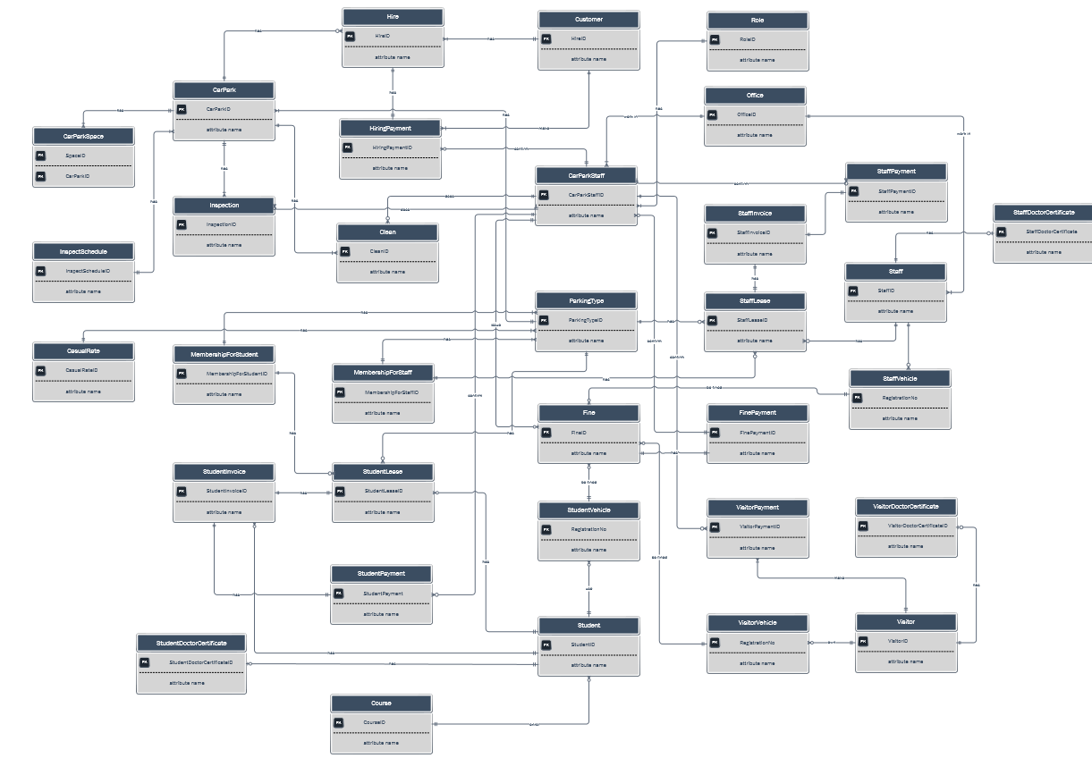

Figure 1. Entity Relationship Diagram of University Car Park Office

1. **Queries**
2. Display a report listing the names and numbers of all staff and students with the details of their car park lease agreements.

SELECT Student.StudentID, Student.FName, Student.LName, StudentLease.StudentLeaseID, StudentLease.Duration, StudentLease.ParkingTypeID, StudentLease.StartDate, StudentLease.EndDate, StudentLease.MembershipForStudentID

FROM Student, StudentLease

WHERE Student.StudentID= StudentLease.StudentID

UNION

SELECT Staff.StaffID, Staff.FName, Staff.LName, StaffLease.StaffLeaseID, StaffLease.Duration, StaffLease.ParkingTypeID, StaffLease.StartDate, StaffLease.EndDate, StaffLease.MembershipForStaffID

FROM Staff, StaffLease

WHERE Staff.StaffID= StaffLease.StaffID;

1. Display the details of the total car park fees paid by all students.

SELECT SUM(Amount) AS StudentTotalPayment FROM StudentPayment;

1. Display the details of the total car park fees paid by all students.

SELECT SUM(Amount) AS StaffTotalPayment FROM StaffPayment;

1. Display details of students that have not paid their car park invoices.

SELECT * FROM Student

WHERE Student.StudentID

IN

(SELECT StudentLease.StudentID FROM StudentLease WHERE StudentLease.StudentLeaseID

IN

(SELECT StudentInvoice.StudentLeaseID FROM StudentInvoice WHERE StudentInvoice.StudentInvoiceID

NOT IN

(SELECT StudentPayment.StudentInvoiceID FROM StudentPayment)));

1. Display details of staffs that have not paid their car park invoices

SELECT *

FROM Staff

WHERE Staff.StaffID

IN

(SELECT StaffLease.StaffID FROM StaffLease WHERE StaffLease.StaffLeaseID

IN

(SELECT StaffInvoice.StaffLeaseID FROM StaffInvoice WHERE StaffInvoice.StaffInvoiceID

NOT IN

(SELECT StaffPayment.StaffInvoiceID FROM StaffPayment)));

1. Display details of students that have paid their invoices

SELECT *

FROM Student

WHERE Student.StudentID

IN

(SELECT StudentLease.StudentID FROM StudentLease WHERE StudentLease.StudentLeaseID

IN

(SELECT StudentInvoice.StudentLeaseID FROM StudentInvoice WHERE StudentInvoice.StudentInvoiceID

IN (SELECT StudentPayment.StudentInvoiceID FROM StudentPayment)));

1. Display details of staffs that have paid their invoices

SELECT *

FROM Staff

WHERE Staff.StaffID

IN

(SELECT StaffLease.StaffID FROM StaffLease WHERE StaffLease.StaffLeaseID

IN

(SELECT StaffInvoice.StaffLeaseID FROM StaffInvoice WHERE StaffInvoice.StaffInvoiceID

IN

(SELECT StaffPayment.StaffInvoiceID FROM StaffPayment)));

1. Display the details of inspections where the car park was found to be in an unsatisfactory condition.

SELECT * FROM Inspection WHERE Inspection.Indication= ‘No’;

1. Display details of students using the university car parks.

SELECT * FROM Student Where Student.StudentID

IN

(SELECT StudentLease.StudentID FROM StudentLease);

1. Display details of staffs using the university car parks.

SELECT * FROM Staff Where Staff.StaffID

IN

(SELECT StaffLease.StaffID FROM StaffLease);

1. Check details of all car parks that are book for Sunday market.

SELECT CarPark.CarParkID, CarPark.Name, CarPark.Location, CarPark.Size, CarPark.Capacity, CarPark.ParkingTypeID, CarPark.CarParkStaffID, Hire.DateofHire, Hire.DateofReturn, Hire.FeePerDay, Hire.CustomerID

FROM CarPark, Hire

WHERE CarPark.CarParkID= Hire.CarParkID;

1. Check the income of all car parks that are booked for Sunday market so far.

SELECT SUM(Amount) FROM HiringPayment;

1. Check all car park fines issued that are not paid.

SELECT * FROM Fine WHERE Fine.FineID

NOT IN

(SELECT FinePayment.FineID FROM FinePayment);

1. Check the telephone number of each staff and their office number.

SELECT CarParkStaff.FName, CarParkStaff.LName, CarParkStaff.PhoneNumber, CarParkStaff.OfficeID

FROM CarParkStaff;

1. Check car parking fees per year and per week for students.

SELECT * FROM MembershipForStudent;